Not responsive (change password)

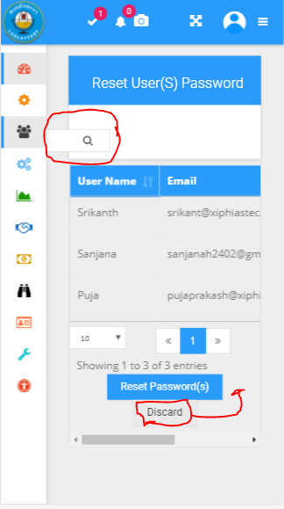

Access denied but already set permission to “All permission”

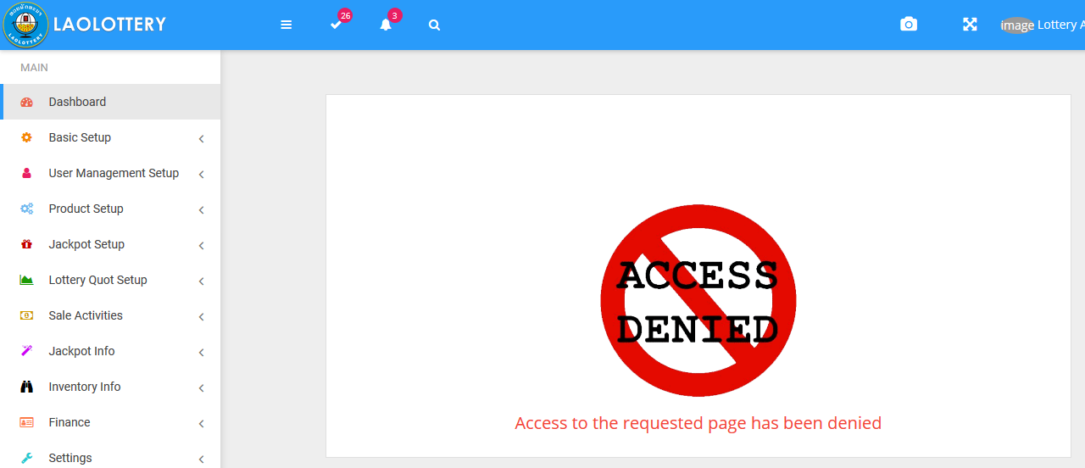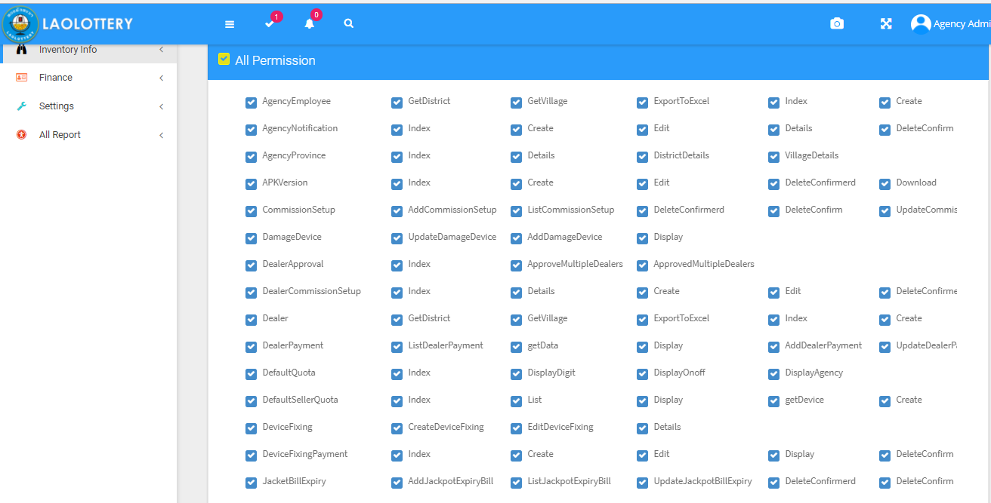

Please change all font to “Phetsarath OT” when using Lao language and the button should not stuck

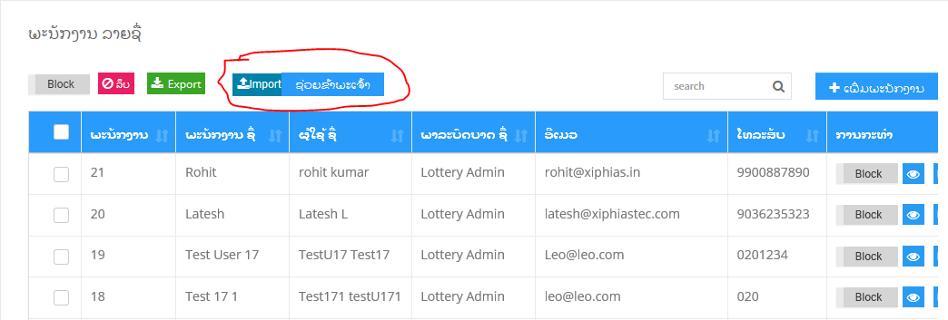

not responsive

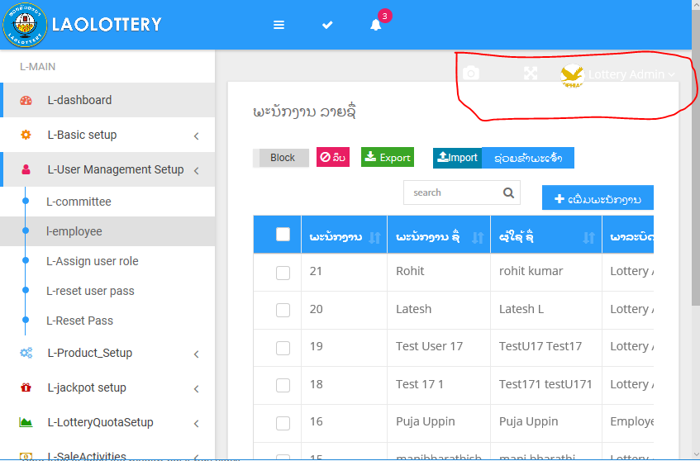

Export and import not working. This is export file but it come with the structure only

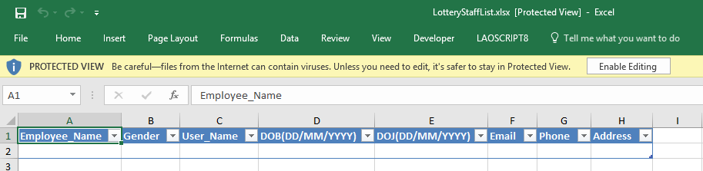

When trying to import this information to database it say successful import but, the data doesn’t come with new data that already import 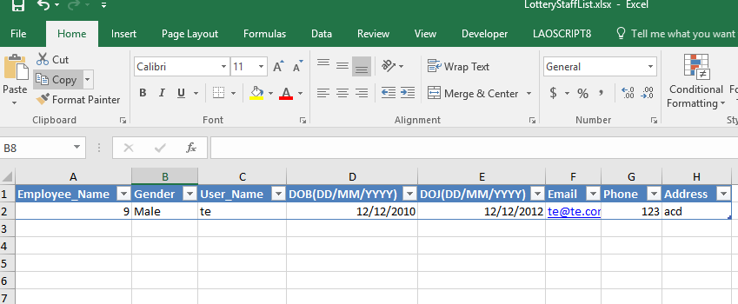

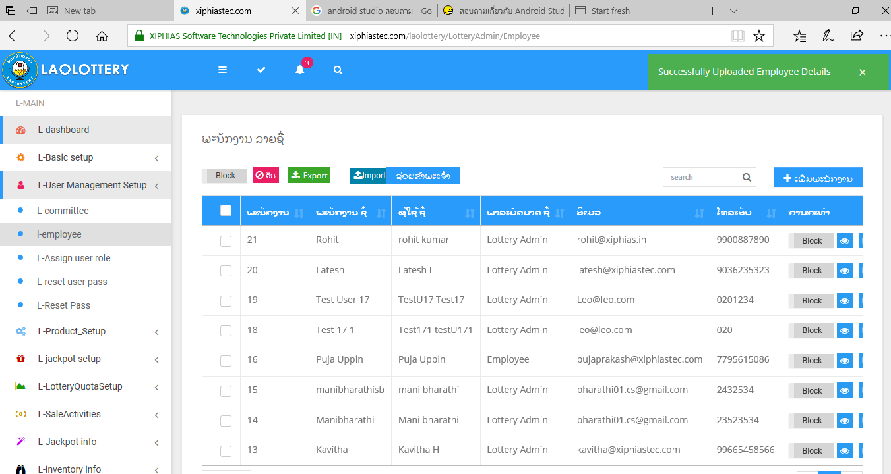

When capture screen it should not allow the table out side the div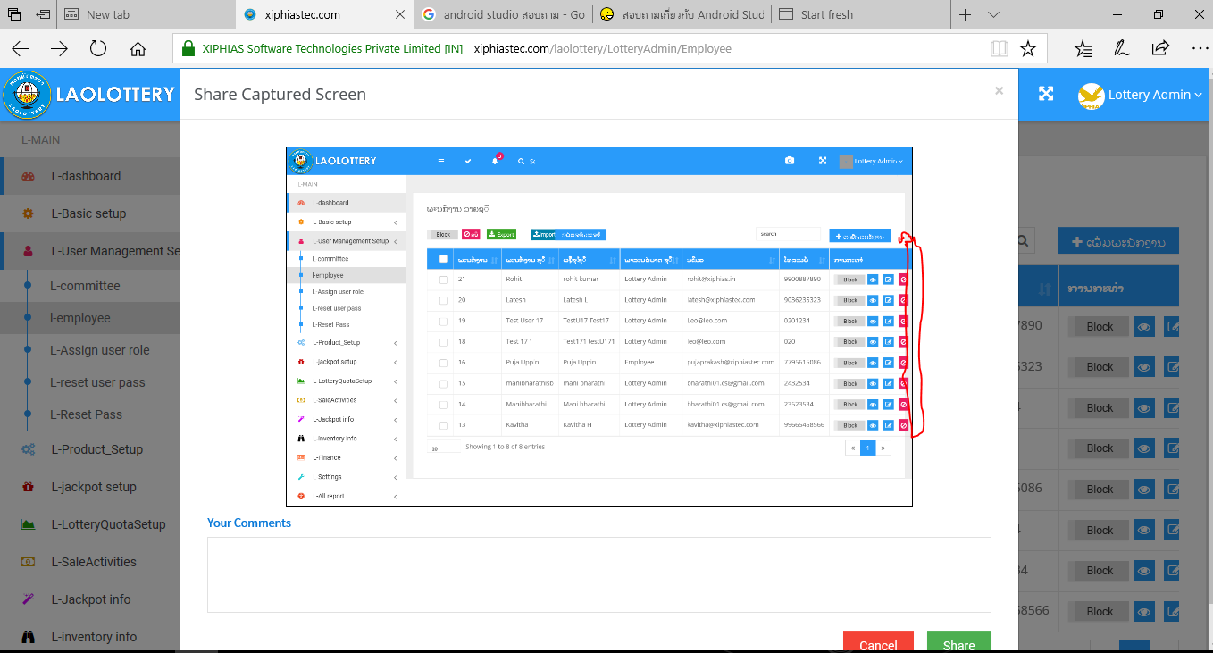

Not responsive

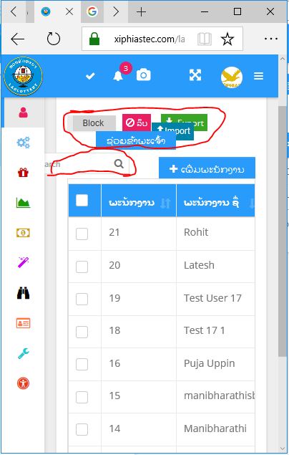

The blue color conceal some word

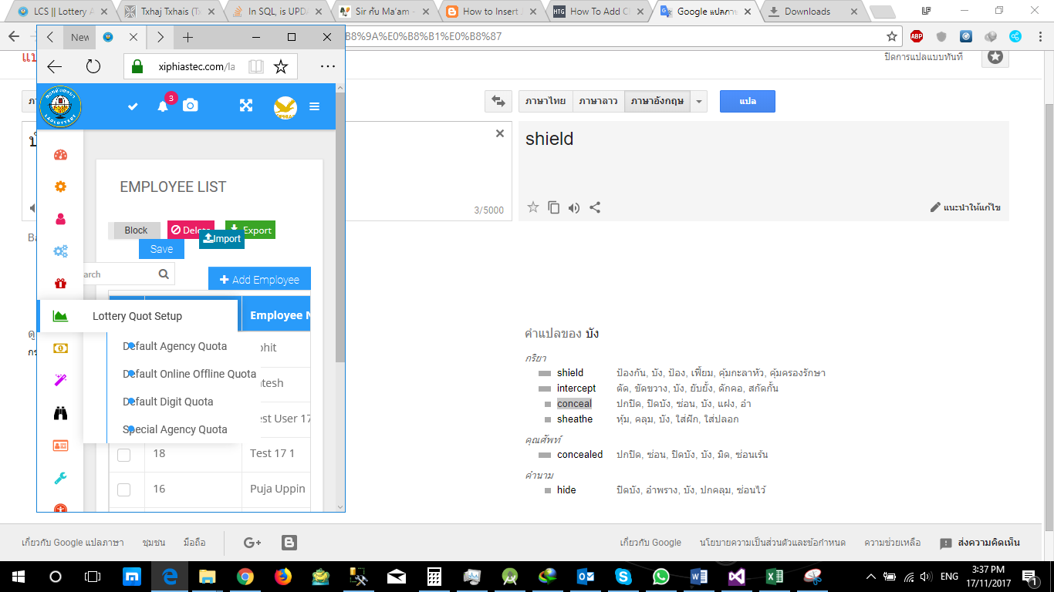 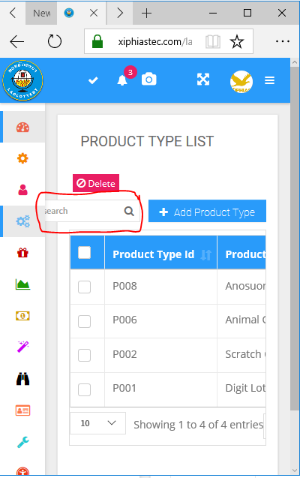

Some time error come with trying to edit Employee

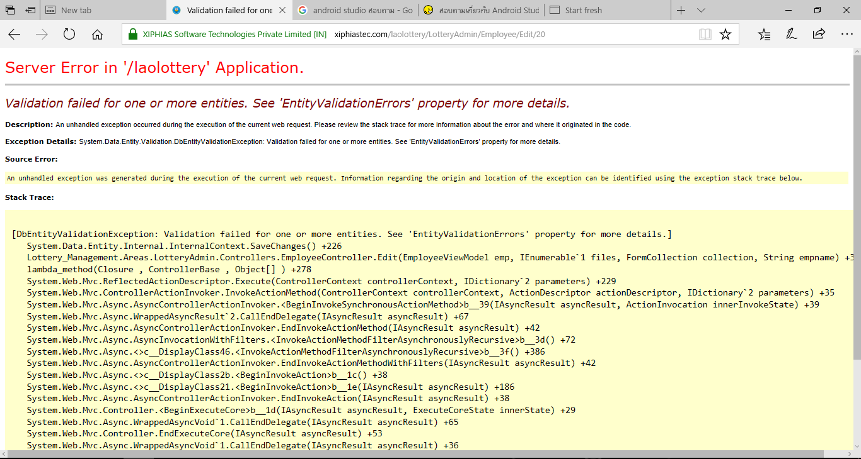

Do not allow to blank

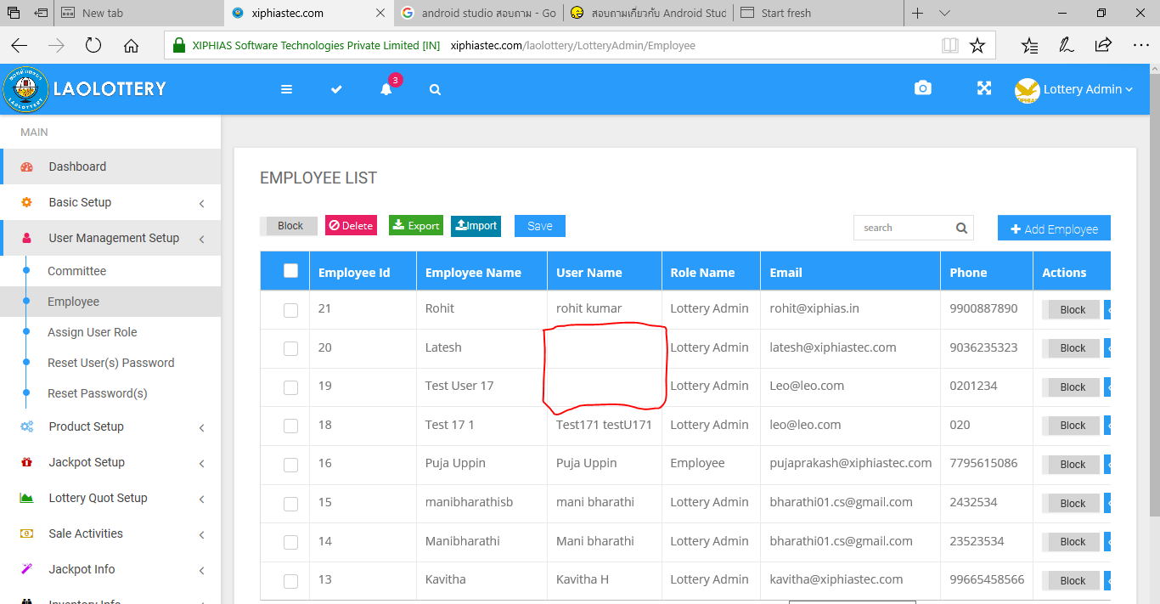

On the view popup must to have a detail of this Role (permission must display inside this popup) not just display only Role ID and Role Name

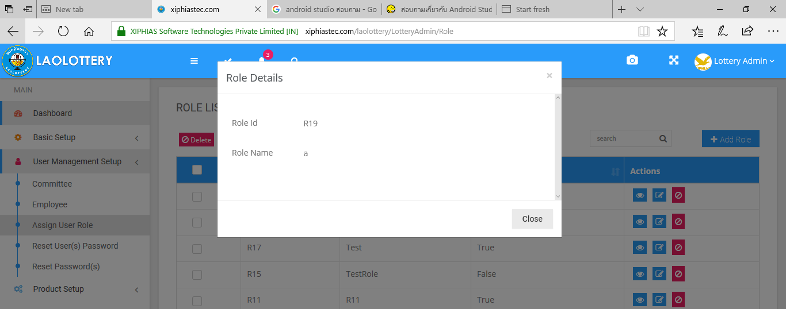

It should display like picture below into the popup when user click view function

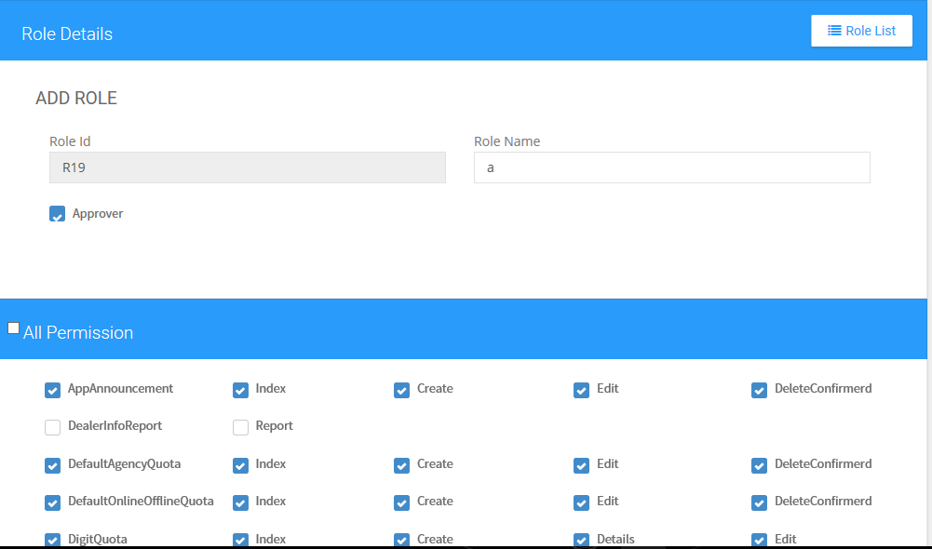

Please provide the “search box” to find information for change password. this function not work please check

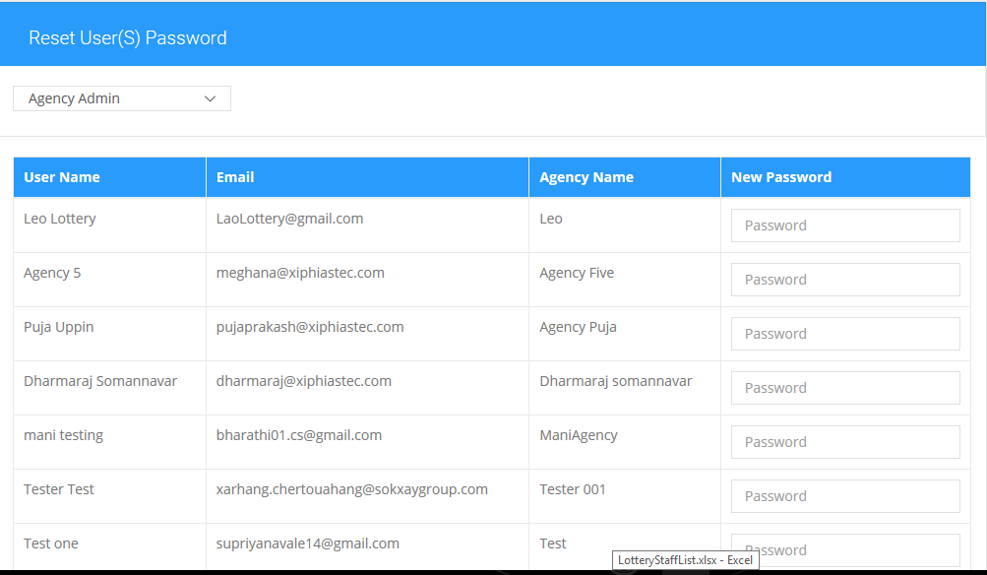

Product name should not allow like this. Using (String). Trim (); to validate this

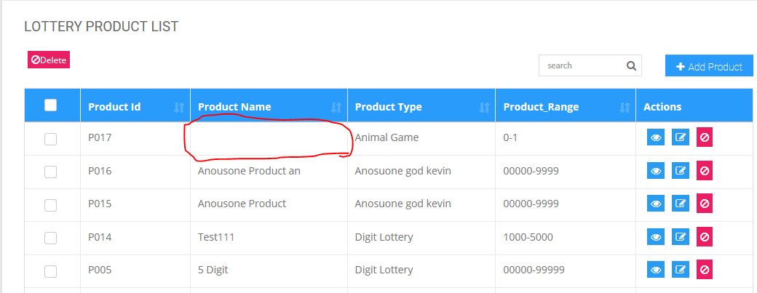

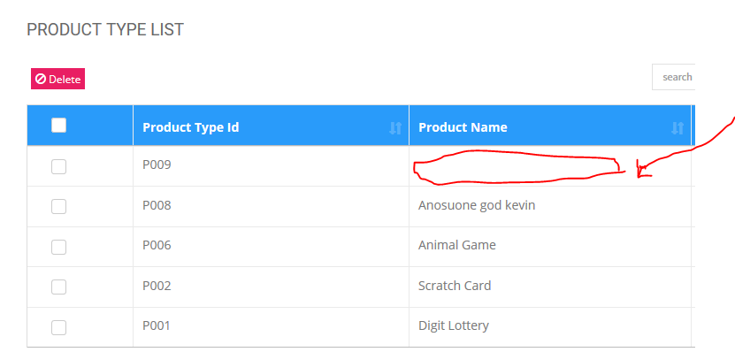

When not select any row this button should not allow to click

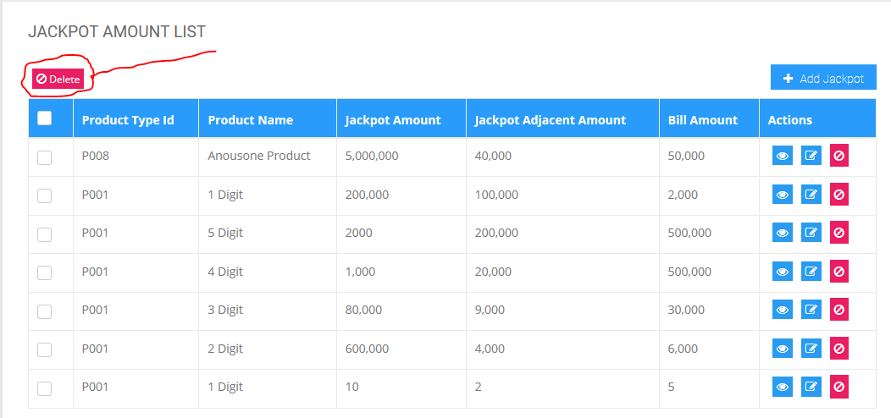

Sometime cannot edit Jackpot Amount it come with this screen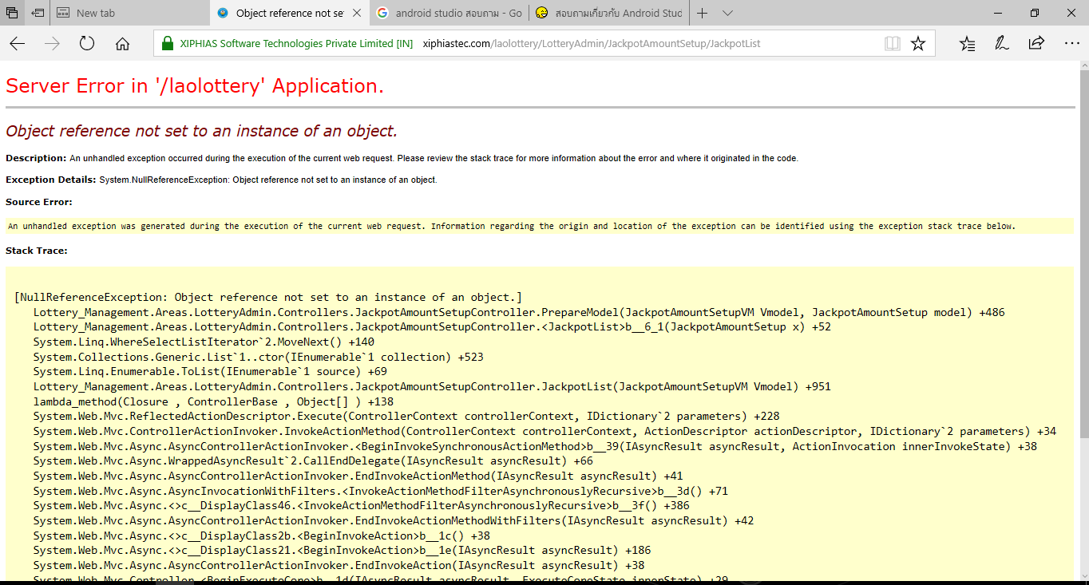

cannot add Jackpot amount it come with this screen

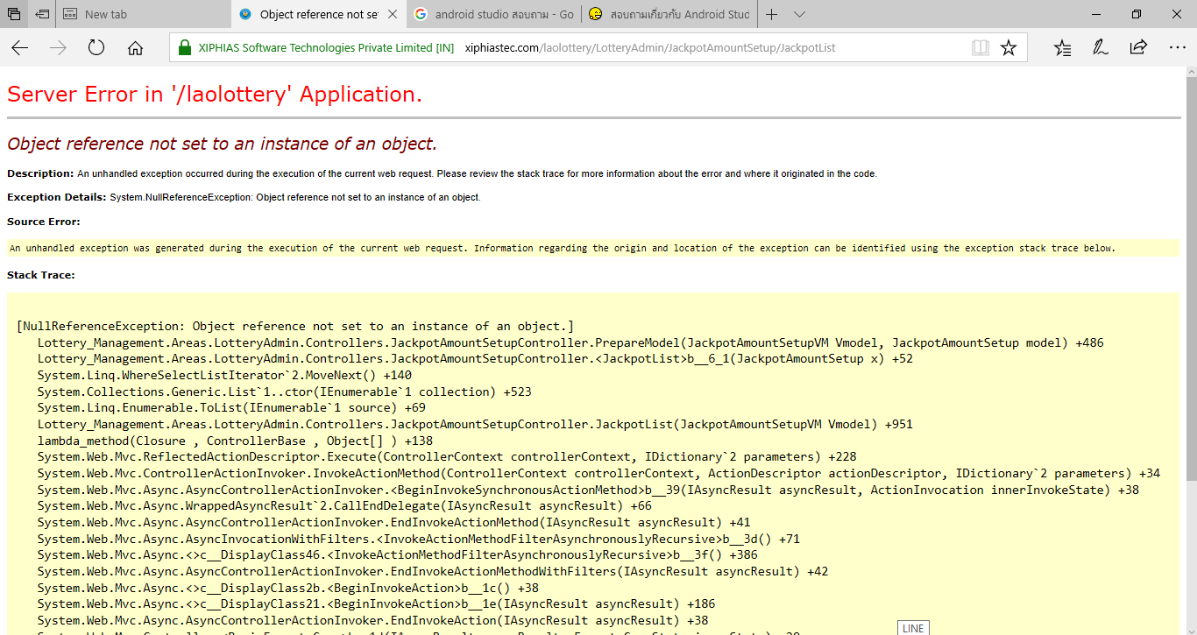

Cannot display Jackpot amount setup (already sent video via whatsapp group)

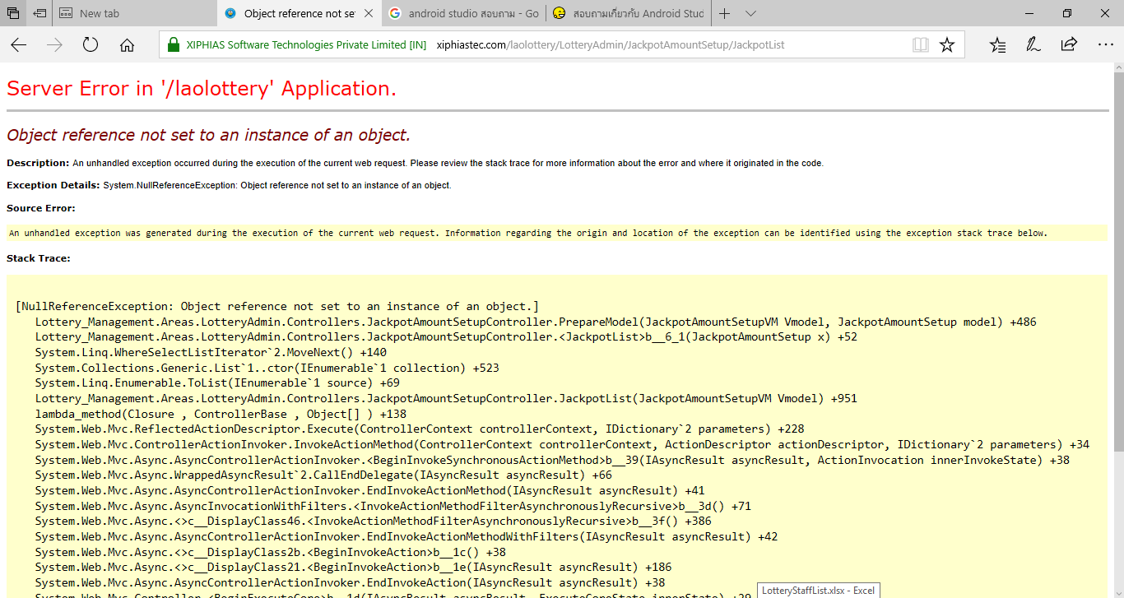

Format number for this box

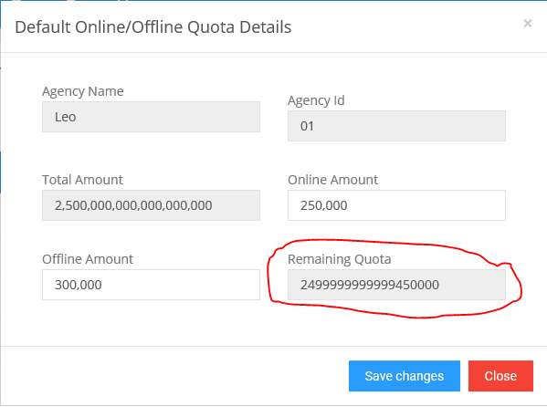

Agency quota detail on the view popup cannot see the lottery date

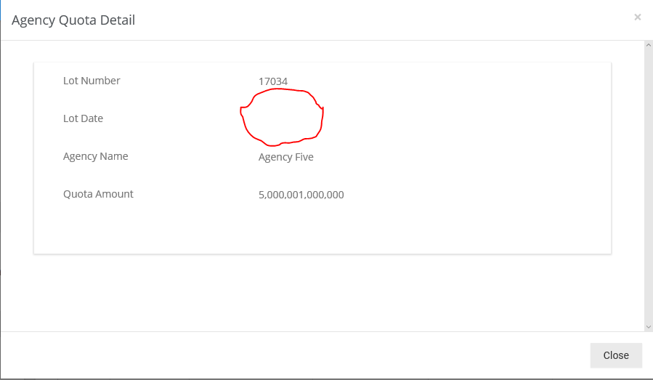

This box must minimum 1000 up and it should end with 000 not allow like 9,234 or 1,332 …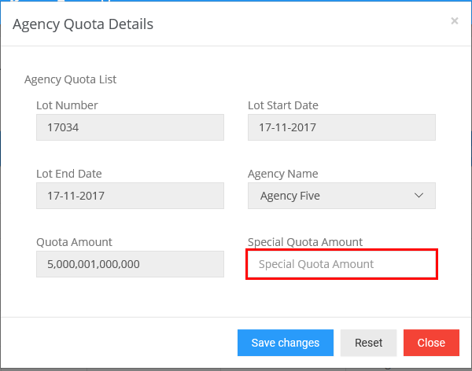

Please check this. This report cannot work and some of word going to new line

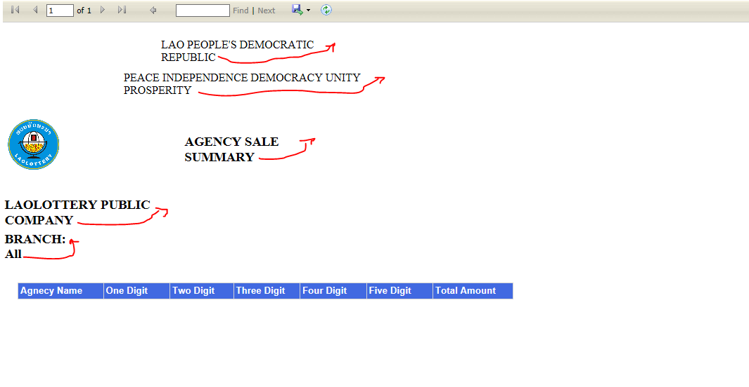

Why it showing multiple blank row

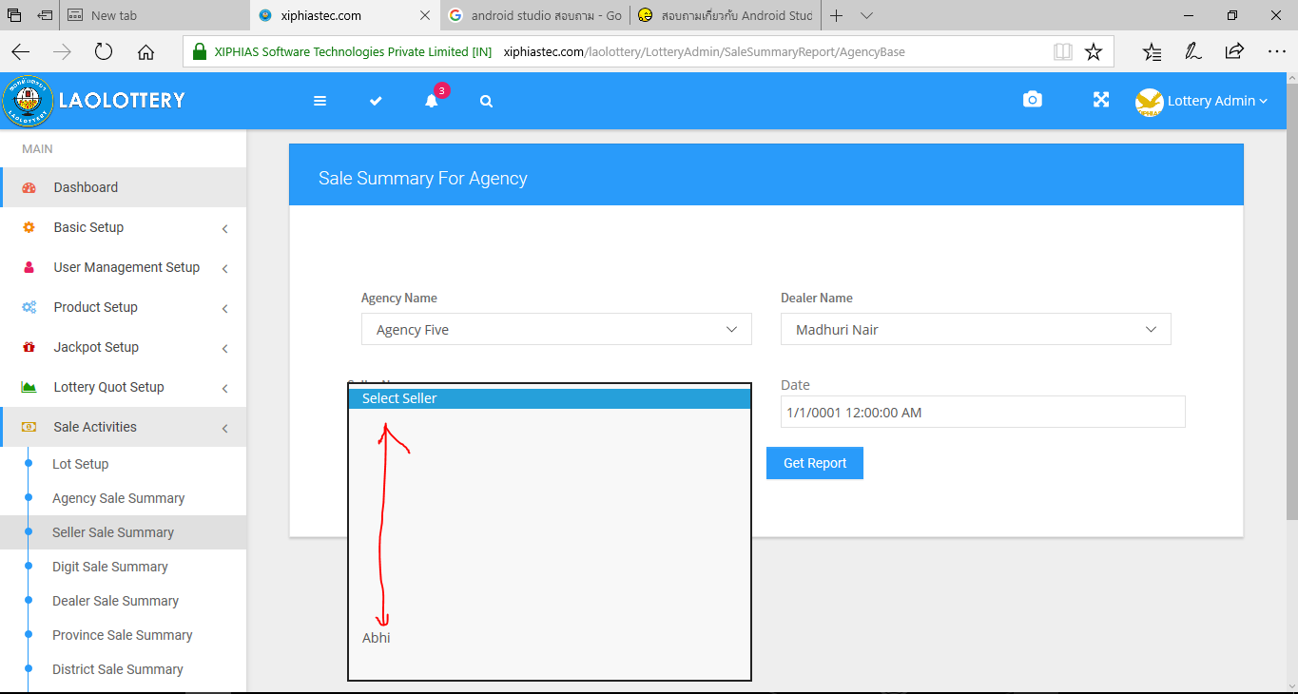

The report should like this

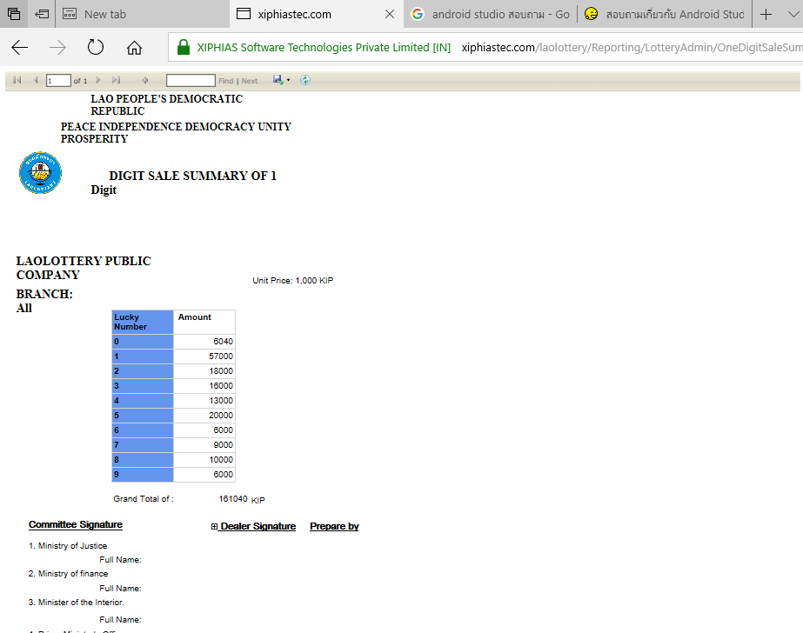 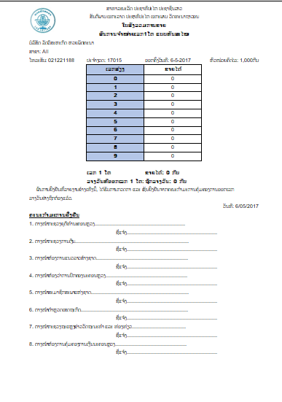

This report not showing any-data

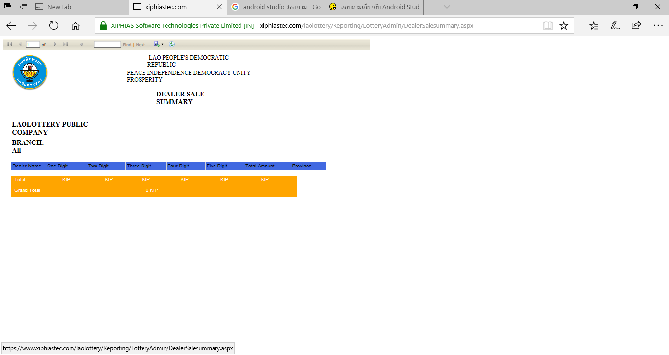

Should not allow user to input information like this

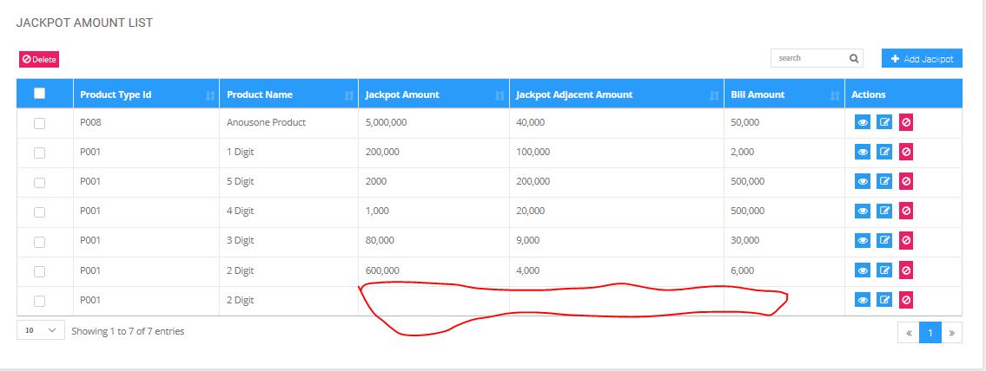

Should allow user to input only numeric

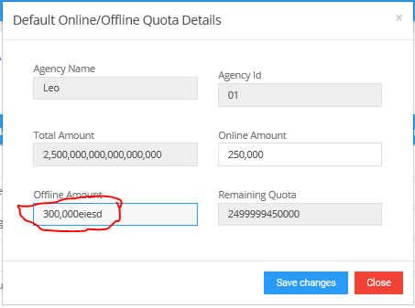

This box should end with x,000 the button should not stuck with the text box

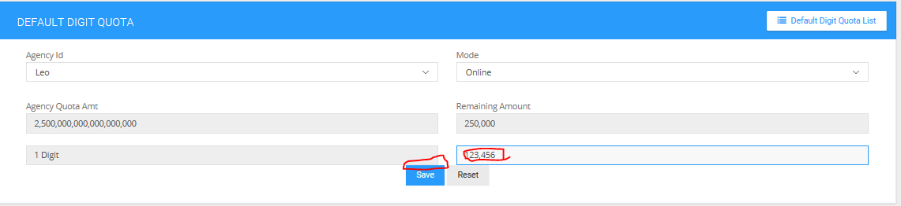

This button not working

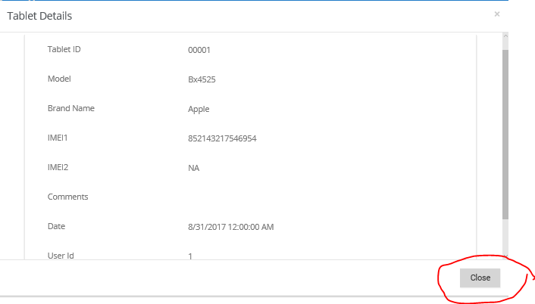

This form is for edit. the title of tab must be “edit table” not “add tablet”

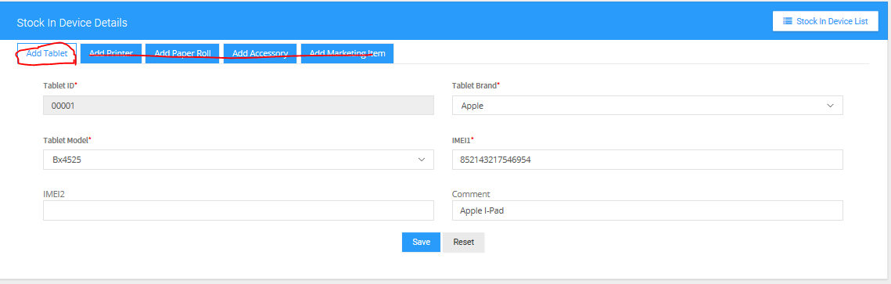

How to filter by lot number

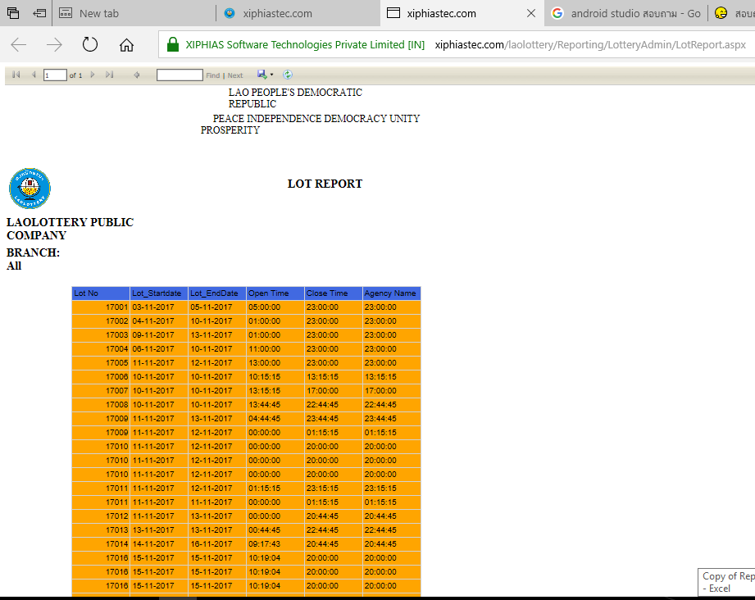

This report not complete yet

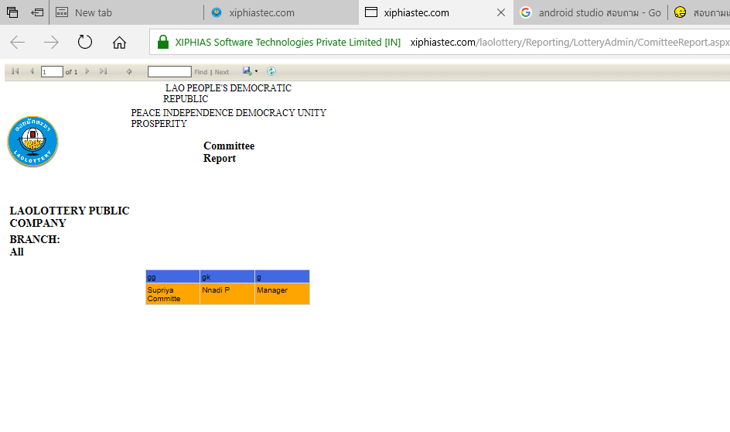

How to filter this report and some word going to new line

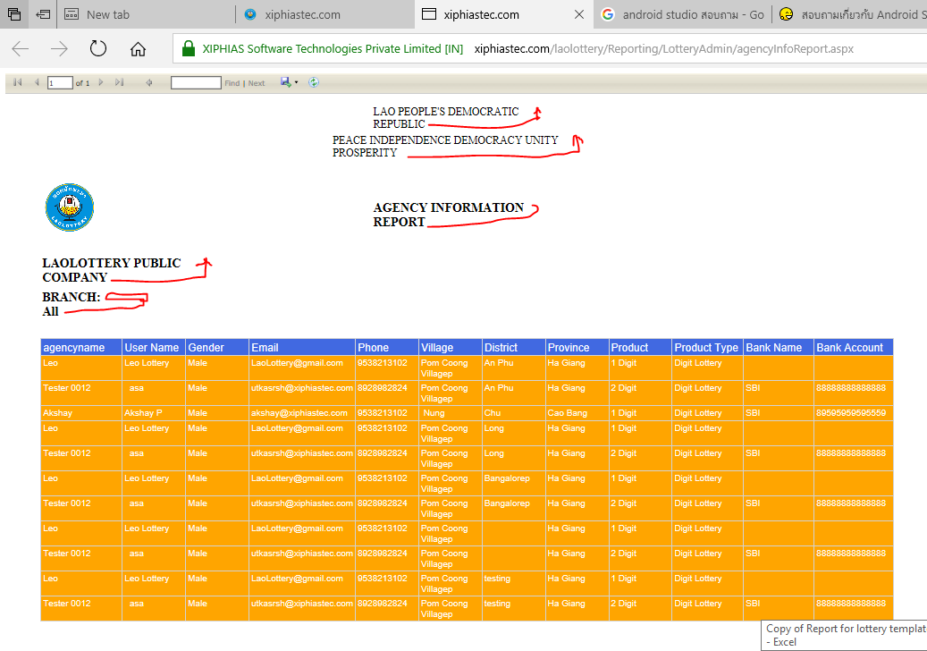

the report should display on the page first, it should have the function to sort or filter and should have a button to print that report. And need to modify because some of word inside report going to new line e.g. the title like

“PEACE INDEPENDENCE DEMOCRACY UNITY   
PROSPERITY”

the PROSPERITY should not going to ne line

this report cannot get any-information

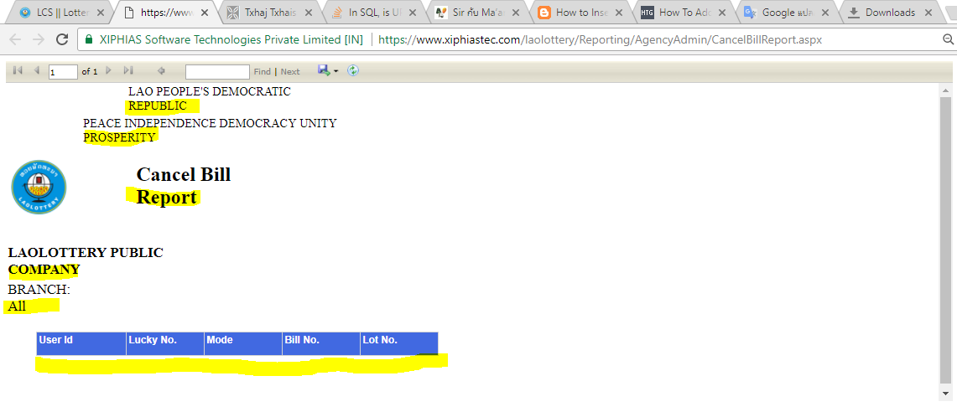

This report don’t have any-row

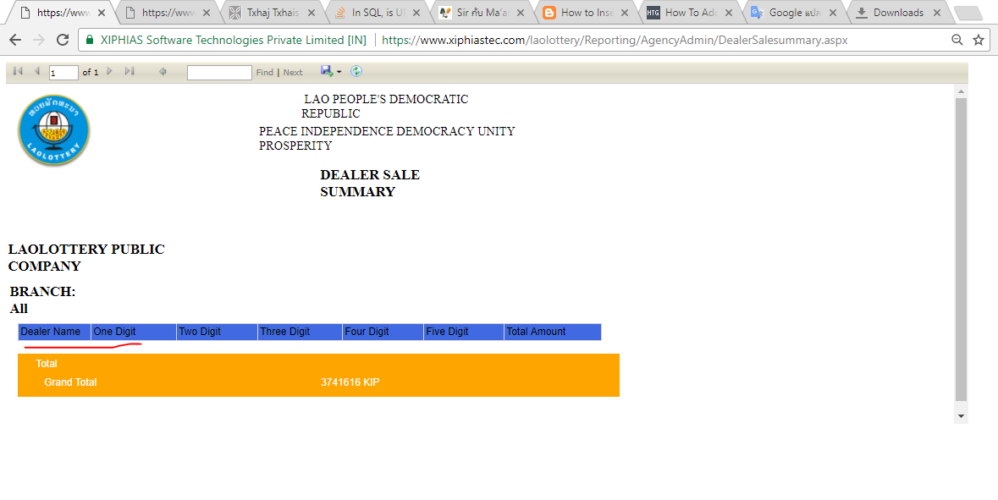

Same Lot showing multiple time